EX NO: 5 | Implementation of an IoT-Based Smart Home Automation Network Using Cisco Packet Tracer
DATE:

Objectives
(i) To design and configure an IoT smart home network with PC-based monitoring and control, integrating IoT devices, an access point, a switch, and an IoT server to enable centralized management of smart appliances.
(ii) To establish smartphone-based Wi-Fi connectivity for remote access and control of IoT devices, and verify wireless communication between the mobile device and the smart home network through the access point and IoT server.
Software/Apparatus required:
(i) Cisco Packet Tracer
(ii) End Devices (PCs)
(iii) Switches
(iv) Copper Straight-through Cable / Automatic Cable Selector
(v) Routers
(vi) Server (DHCP)
(vii) Household devices (Fan, AC, Light, Garage door)
Procedure:
Objective 1: PC based monitoring
1. Open Cisco Packet Tracer and create a new workspace.
2. Add a Home Gateway/Access Point, Switch, Server, PC, and IoT devices (Fan, Air Conditioner, Garage Door, and Light).
3. Connect the Server and Home Gateway to the Switch using copper straight-through cables.
4. Configure IP addressing for the Server and PC.
5. Enable IoT services on the Server and create a user account.
6. Connect the IoT devices wirelessly to the Home Gateway.
7. Register all IoT devices with the IoT Server.
8. Verify that the devices appear in the IoT Server dashboard.
9. Access the IoT Server from the PC using a web browser.
10. Monitor and control the IoT devices through the PC interface and verify their operation. Objective 2: Smartphone-based monitoring
1. Open the configured IoT smart home topology in Cisco Packet Tracer. 2. Add a Smartphone and ensure the Home Gateway/Access Point is active. 3. Configure the wireless network (SSID and password) on the Home Gateway. 4. Connect the Smartphone to the Wi-Fi network using the configured SSID. 5. Ensure the Smartphone obtains an IP address automatically.
6. Open the IoT monitoring application or web browser on the Smartphone. 7. Log in to the IoT Server using the registered user credentials.
8. Access the list of connected IoT devices.
9. Remotely monitor and control the Fan, Air Conditioner, Garage Door, and Light using the Smartphone.
10. Verify that the device status changes according to the commands issued from the Smartphone.
Objective 1: PC based monitoring

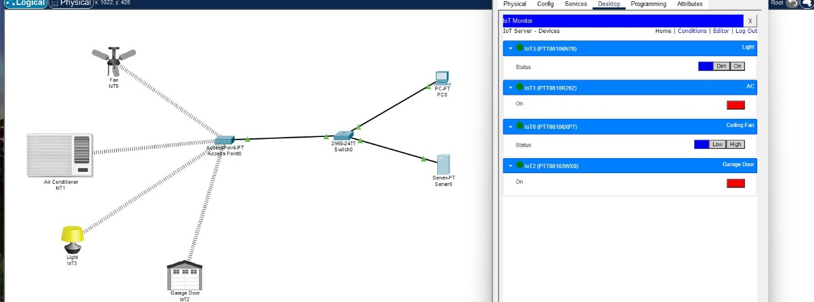

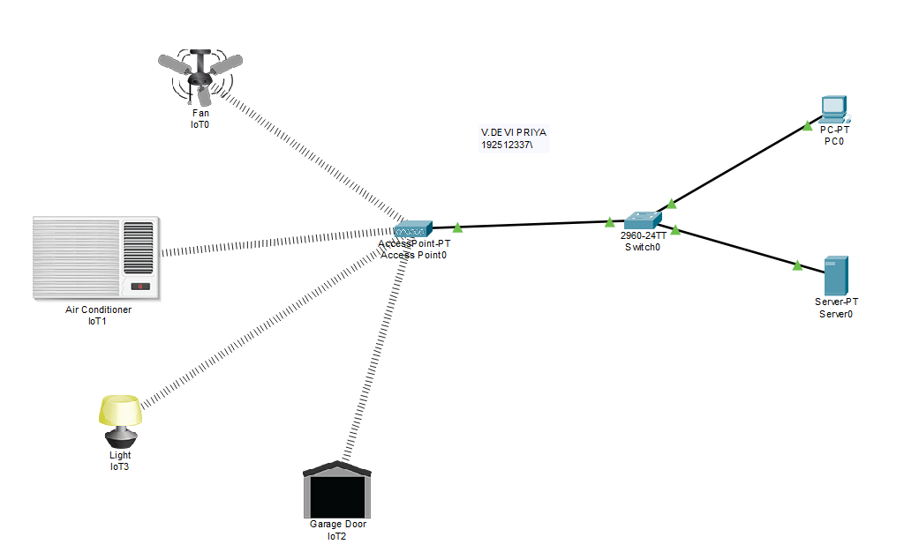Objective 2: Smart phone based monitoring

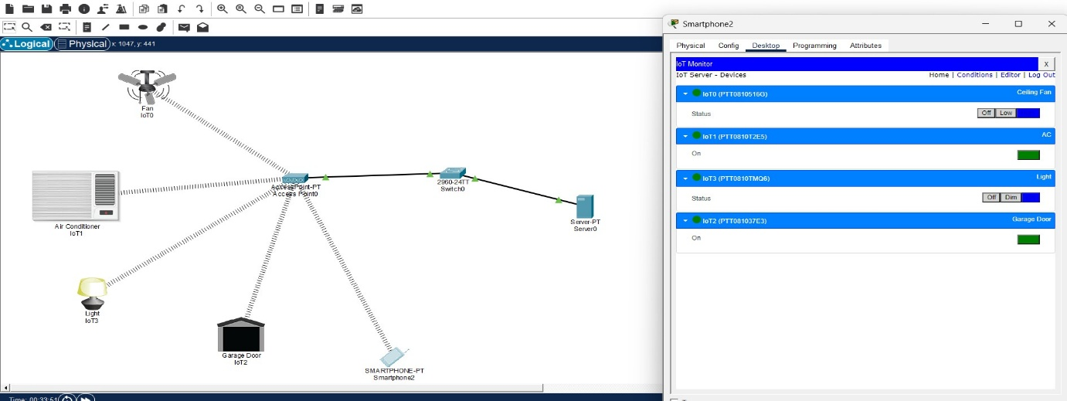

Objective 1: PC based monitoring
Things | Default | Control
Fan | Off | ON,LOW,HIGH
AC | Off | ON,OFF
Garage Door | Open | CLOSE,OPEN
Light | Dim | ,OFF,DIM,ON

Objective 2: Smart phone based monitoring
Things | Default | Control
Fan | Off | ON,LOW,HIGH
AC | Off | ON,OFF
Garage Door | Open | CLOSE,OPEN
Light | Dim | OFF,DIM,ON

Result
Objective 1: PC based monitoring
The IoT smart home network was successfully configured, and the PC was able to monitor and control the connected IoT devices through the server.
Objective 2: Smart phone based monitoring
The smartphone was successfully connected to the Wi-Fi network and was able to remotely monitor and control the IoT devices.
Test Case Question 1
Implement the specified IoT Smart Home topology using Cisco Packet Tracer and analyze PC based monitoring and control of IoT devices through an IoT server.
Case 1
∙ Number of PCs: 1
∙ Number of Switches: 1
∙ Number of Home Gateways/Access Points: 1
∙ Number of IoT Servers: 1
∙ Number of IoT Devices: 4 (Fan, Air Conditioner, Garage Door, Light) ∙ Access Method: PC-Based Monitoring
Case 2
∙ Number of PCs: 2
∙ Number of Switches: 1
∙ Number of Home Gateways/Access Points: 1
∙ Number of IoT Servers: 1
∙ Number of IoT Devices: 6 (Fan, Air Conditioner, Garage Door, Light, Webcam, Smoke Detector)
∙ Access Method: PC-Based Monitoring
Tasks
1. Construct the specified topology and configure the IoT server and home gateway. 2. Register the IoT devices with the IoT server and establish network connectivity. 3. Access the IoT server from the PC and verify monitoring and control of all IoT devices.
Test Case Question 2
Implement the specified IoT Smart Home topology using Cisco Packet Tracer and analyze smartphone-based Wi-Fi monitoring and control of IoT devices.
Case 1
∙ Number of Smartphones: 1
∙ Number of Switches: 1
∙ Number of Home Gateways/Access Points: 1
∙ Number of IoT Servers: 1
∙ Number of IoT Devices: 4 (Fan, Air Conditioner, Garage Door, Light) ∙ Access Method: Mobile Wi-Fi Control
Case 2
∙ Number of Smartphones: 2
∙ Number of Switches: 1
∙ Number of Home Gateways/Access Points: 1
∙ Number of IoT Servers: 1
∙ Number of IoT Devices: 6 (Fan, Air Conditioner, Garage Door, Light, Webcam, Smoke Detector)
∙ Access Method: Mobile Wi-Fi Control
∙ Wireless Network: Secured Wi-Fi Connection
Tasks
1. Construct the specified topology and configure the IoT server, home gateway, and Wi-Fi settings.
2. Connect the smartphones to the wireless network and register the IoT devices with the server.
3. Access the IoT server from the smartphones and verify remote monitoring and control of all IoT devices

